Multi-Disease Prediction

A project report submitted in fulfillment of the requirement for the degree of



BTech
In
Computer Science
Under the supervision of
Mr. Anugrah Srivastava

By

Yati Singh
Anushka Srivastava
Aditya Singh Dalla

DECLARATION

We confirm that this submission is our own work and that, to the best of our knowledge and belief, it contains no material previously published or written by another person nor material which to a substantial extent has been accepted for the award of any other degree or diploma of the university or other institute of higher learning, except where due acknowledgment has been made in the text.

Name: Yati Singh
Roll No.: E23CSEU1058
Date:17.11.25

Name: Anushka Srivastava
Roll No.: E23CSEU1070
Date:17.11.25

Name: Aditya Singh Dalla
Roll No.: E23CSEU1051
Date:17.11.25

CERTIFICATE

This is to certify that the Project Report entitled “Multi Disease Prediction” which is submitted by Yati Singh ,Anushka Srivastava and Aditya Singh Dalla in partial fulfillment of the requirement for the award of degree B. Tech. in the School of Computer Science of Bennett University, is a record of the candidate's own work carried out by him under my/our supervision. The matter embodied in this report is original and has not been submitted for the award of any other degree.

Supervisor:
Mr. Anugrah Srivastava

ACKNOWLEDGEMENT

It gives us a great sense of pleasure to present the report of the B. Tech Project undertaken during B. Tech. Third Year. We owe a special debt of gratitude to Mr. Anugrah Srivastava, School of Computer Science of Bennett University, for his constant support and guidance throughout the course of our work. His sincerity, thoroughness, and perseverance have been a constant source of inspiration for us. It is only his cognizant efforts that our endeavors have seen the light of the day.
We also do not like to miss the opportunity to acknowledge the contribution of all faculty members of the department for their kind assistance and cooperation during the development of our project. Last but not the least, we acknowledge our friends for their contribution to the completion of the project.

Name: Yati Singh
Roll No.: E23CSEU1058
Date: 17.11.25

Name: Anushka Srivastava
Roll No.: E23CSEU1070
Date: 17.11.25

Name: Aditya Singh Dalla
Roll No.: E23CSEU1051
Date: 17.11.25

TABLE OF CONTENTS

DECLEARATION…………………………………………………1

CERTIFICATE………………………………………………………2

ACKNOWLEDGMENT……………………………………………3

ABSTRACT………………………………………………………4

INTRODCTION……………………………………………………5

LITERATURE REVIEW…………………………………………………………6

DATASET DESCRIPTION & PREPROCESSING………………………….7

METHODOLOGY……………………………………………………………..8

RESULTS & DISCUSSION……………………………………………………9

CONCLUSION & FUTURE WORK……………………………………….10

REFERENCES………………………………………………………………..11

APPENDIX………………………………………………………………12

Abstract

This project presents an integrated Multi-Disease Prediction System that leverages a hybrid machine learning architecture to support predictive healthcare applications. The system is built on two complementary components: a symptom-based multi-disease classifier capable of predicting forty-two common diseases, and a structured, configuration-driven pipeline designed for disease-specific datasets such as diabetes and heart disease. The symptom model processes raw symptom inputs using extensive one-hot encoding and sparse matrix transformation before classification using an XGBoost model. It achieves a high test accuracy of 97.62% on the provided benchmark dataset, demonstrating its ability to learn meaningful patterns from symptom combinations. The second component of the project is a rigorous machine learning pipeline applied to structured clinical datasets, particularly the Pima Indians Diabetes dataset. This pipeline integrates preprocessing, feature engineering, cross-validation-safe target encoding, model selection, hyperparameter tuning, and the construction of an ensemble stacking classifier. It is fully governed by an external configuration file to ensure reproducibility. Both models are deployed through a unified Streamlit application, enabling users to predict general diseases from symptoms as well as obtain disease-specific predictions using trained ML models. Overall, the project contributes a scalable, interpretable, and deployable hybrid system for medical decision support.

Introduction

Healthcare diagnosis often requires interpreting complex, overlapping, and sometimes vague symptoms. Traditional diagnostic processes are time-consuming and heavily dependent on the expertise of medical professionals. With the evolution of machine learning techniques, there is growing potential to build intelligent systems capable of assisting in rapid disease identification. The motivation for this project stems from the increasing need for automated decision-support systems that can analyse both subjective symptom inputs as well as structured clinical data to produce accurate predictions.
The primary objective of this project is to build a comprehensive multi-disease prediction system that utilizes two complementary architectures. The first focuses on symptom-based prediction, where patient-reported symptoms are processed to infer one among forty-two possible diseases. This component is essential for cases where only qualitative information is available. The second objective is to construct a robust, extensible machine learning pipeline for clinical datasets, where diseases are predicted based on measurable physiological attributes. The project integrates multiple stages such as feature engineering, preprocessing, hyperparameter tuning, model evaluation, and ensemble learning. Another major objective is to deploy the models through an intuitive user interface, enabling easy interaction and real-time predictions.
To deliver a complete system, the report begins with a literature review, followed by a detailed explanation of datasets and preprocessing steps, a comprehensive methodology section, an analysis of results, and a final discussion on conclusions and future enhancements.

Literature Review
Machine learning for medical diagnosis has been extensively explored in recent years, with research focusing on both symptom-based and clinical parameter-based predictive modelling. Early works such as Kumar and Singh (2019) utilized decision-tree algorithms to classify diseases from small symptom datasets, demonstrating promising accuracy but limited scalability due to the small number of diseases considered. Expanding on these foundations, Ghosh and Maity (2020) experimented with neural network models for multi-class disease prediction. Although neural networks captured non-linear symptom interactions effectively, the models struggled with generalization due to limited dataset diversity and symptom overlap.
The use of structured medical datasets such as the Pima Diabetes dataset has been equally well studied. Chaudhary et al. (2021) applied XGBoost and highlighted how tree-based ensemble methods perform well on noisy medical datasets. Similarly, Uddin et al. (2022) demonstrated that stacking classifiers significantly improve heart-disease prediction accuracy by combining the strengths of multiple base learners. Another important study by Chen and He (2020) emphasized the need for cross-validation-safe target encoding to avoid information leakage in datasets containing categorical variables.
A critical gap in existing research is the lack of unified systems capable of predicting multiple diseases using hybrid data sources. Many studies focus only on specific diseases, while others rely solely on symptoms without incorporating structured datasets. Furthermore, most research lacks deployment-ready solutions. This project addresses these gaps by offering a dual-architecture system that combines large-scale symptom-based prediction with structured clinical modeling, all integrated into a fully functioning Streamlit application.

Dataset Description and Preprocessing
The project relies on multiple datasets that collectively support both major components of the system. The primary dataset for the symptom-based model is dataset.csv, which contains forty-two disease classes mapped to up to seventeen symptom columns. These symptoms are initially stored as text identifiers, which required transformation into numerical formats for machine learning. To encode the symptoms efficiently, every unique symptom across the dataset was assigned a binary indicator, resulting in a high-dimensional, 133-feature one-hot encoded vector. This transformation was performed by train.py, which converted the raw dataset into a sparse matrix stored as clean_dataset.tsv. Missing symptom entries were interpreted as symptom absence and encoded with a zero value.
For the knowledge-based components, two supplementary datasets were used: symptom_description.csv, containing descriptive information about each disease, and symptom_precaution.csv, providing precautionary steps recommended for the predicted condition. These files support the interpretability and user experience aspect of the deployed system.
The structured ML pipeline primarily uses the pima_diabetes.csv dataset from the UCI Machine Learning Repository. The dataset includes eight numerical clinical features such as glucose level, BMI, insulin concentration, and blood pressure. Preprocessing for this dataset involved handling missing values, scaling numerical features using StandardScaler, and generating domain-specific engineered variables such as interaction terms (e.g., glucose × BMI). Since categorical features were limited, target encoding was used with K-fold cross-validation to ensure the absence of data leakage.
The dataset was divided using an 80–20 train-test split. The entire preprocessing workflow was controlled by config.yml, which enabled consistent and reproducible results across multiple experiments.

Methodology

The methodology for this project is built around a dual-architecture machine learning approach. The first architecture focuses on symptom-driven disease prediction. After preprocessing the raw dataset, the system generates a high-dimensional binary vector representing symptom presence. This vector is passed into an XGBoost classifier, chosen for its ability to handle sparse, high-dimensional input and capture complex, non-linear relationships among symptoms. The model is trained to classify one among forty-two diseases. Supporting functions in helper.py convert user-entered symptoms into the required NumPy array format for real-time prediction in the Streamlit interface. The DiseaseModel.py script additionally retrieves descriptions and precaution information for the predicted disease, providing users with contextual knowledge beyond the prediction.
The second architecture is a full-fledged machine learning pipeline designed for structured clinical datasets. The pipeline integrates multiple modules, each responsible for a different stage of the modelling process. The workflow begins with configuration loading through config_utils.py, followed by data preparation in data_prep.py, which performs scaling, encoding, and splitting. Essential feature engineering is handled by feature_engineer.py, which creates meaningful interaction terms that help improve model accuracy.
The model selection process uses a model factory defined in models.py, which evaluates a range of algorithms including Logistic Regression, Random Forest, XGBoost, Gradient Boosting, CatBoost, KNN, and SVM. Cross-validation is employed to identify the strongest performers. The best base learners are then combined into a stacking classifier with a Logistic Regression meta-learner, allowing the ensemble to leverage diverse model strengths. Hyperparameter tuning is controlled by Optuna settings defined in config.yml. The entire pipeline is orchestrated by training.py and executed via run_pipeline.py.
Finally, model deployment is achieved through a Streamlit application that integrates both architectures. The app’s sidebar allows users to select general symptom-based prediction or disease-specific prediction modules such as diabetes or heart disease. Models are loaded using joblib files generated by the pipeline.

Results and Discussion
The symptom-based multi-disease classification model demonstrated strong performance, achieving a test accuracy of 97.62% and a weighted F1-score of 0.98 using the Testing.csv evaluation set. Out of forty-two diseases, the model correctly predicted forty-one and misclassified only one case (Paralysis), indicating strong pattern recognition capabilities. However, since the evaluation dataset contains only one sample per disease, the accuracy does not fully reflect real-world performance. The results highlight the model’s strength but also underscore the importance of acquiring a more diverse test set for future evaluation.
In the structured ML pipeline, the model factory identified the ExtraTrees classifier as the best base model with a cross-validation accuracy of 0.8516. CatBoost and Gradient Boosting followed closely with 0.8438 and 0.8399 respectively. These top-performing models were passed into the stacking classifier, which served as the final ensemble. On the holdout test set, the stacking model achieved an accuracy of 0.7597. Although this is lower than the symptom-based model, it is consistent with published results for the Pima Diabetes dataset. The model’s performance is influenced by inherent dataset imbalance, feature noise, and the limited number of clinical parameters available. Visualizations such as ROC curves, confusion matrices, and learning curves (especially from CatBoost) showed smooth convergence and stable training.
The results collectively demonstrate that hybrid machine learning systems can provide both breadth and depth in medical diagnosis: the symptom-based model covers a wide range of diseases, while the structured pipeline offers more precise analysis for datasets with measurable clinical features.

Conclusion and Future Work
This project successfully presents a unified, hybrid machine learning system for disease prediction. The symptom-based model effectively predicts a large number of diseases using simple user-reported inputs, and the structured machine learning pipeline demonstrates reliable performance on clinical datasets. The integration of these models into a Streamlit application makes the system accessible, interactive, and suitable for practical deployment.
Despite these achievements, several limitations remain. The symptom dataset is limited in sample diversity, resulting in inflated evaluation metrics. The structured datasets, while more reliable, cover only specific diseases such as diabetes. The system also lacks deep interpretability features, such as SHAP value explanations, which could significantly enhance clinical acceptance.
Future work may involve expanding the symptom dataset, acquiring real clinical data from hospitals, implementing deep learning models such as BERT for medical text or LSTM for patient history, and extending the system to include additional diseases. Another potential enhancement involves building a mobile-friendly interface and integrating APIs for hospital database connectivity.

References
(You may format these as APA depending on your requirement)
Chen, T., & He, T. (2020). XGBoost: A scalable tree boosting system.
UCI Machine Learning Repository – Pima Indians Diabetes Dataset.
Chaudhary, A., et al. (2021). Machine learning techniques for diabetes prediction.
Ghosh, S., & Maity, P. (2020). Neural network approaches in medical diagnosis.
Kumar, H., & Singh, A. (2019). Decision tree-based disease classification.
Uddin, M. et al. (2022). Stacking classifiers for improved heart disease prediction.
Hastie, T., Tibshirani, R., & Friedman, J. (2017). The Elements of Statistical Learning.
Streamlit Documentation (2024).
Scikit-learn Documentation (2024).
Pima Diabetes Research Group (2020).

APPENDIX

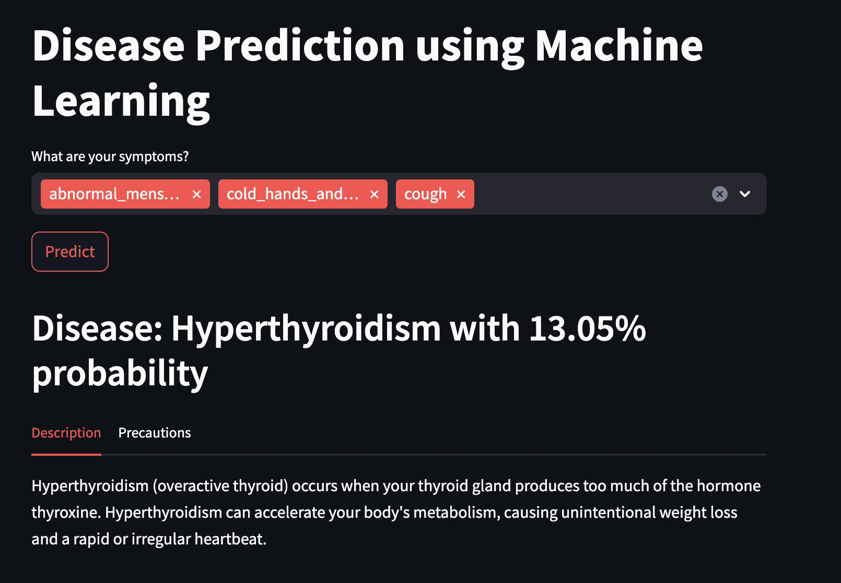
Fig(a)

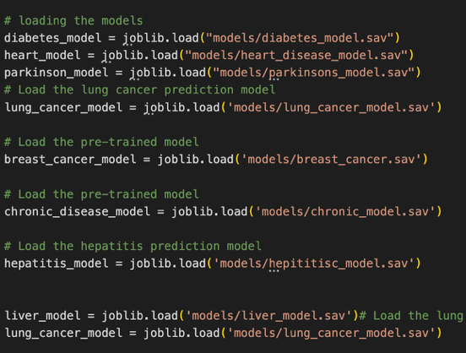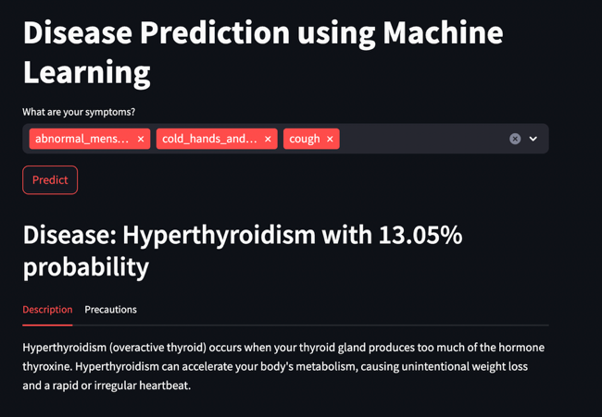
Fig(b). Fig(c)

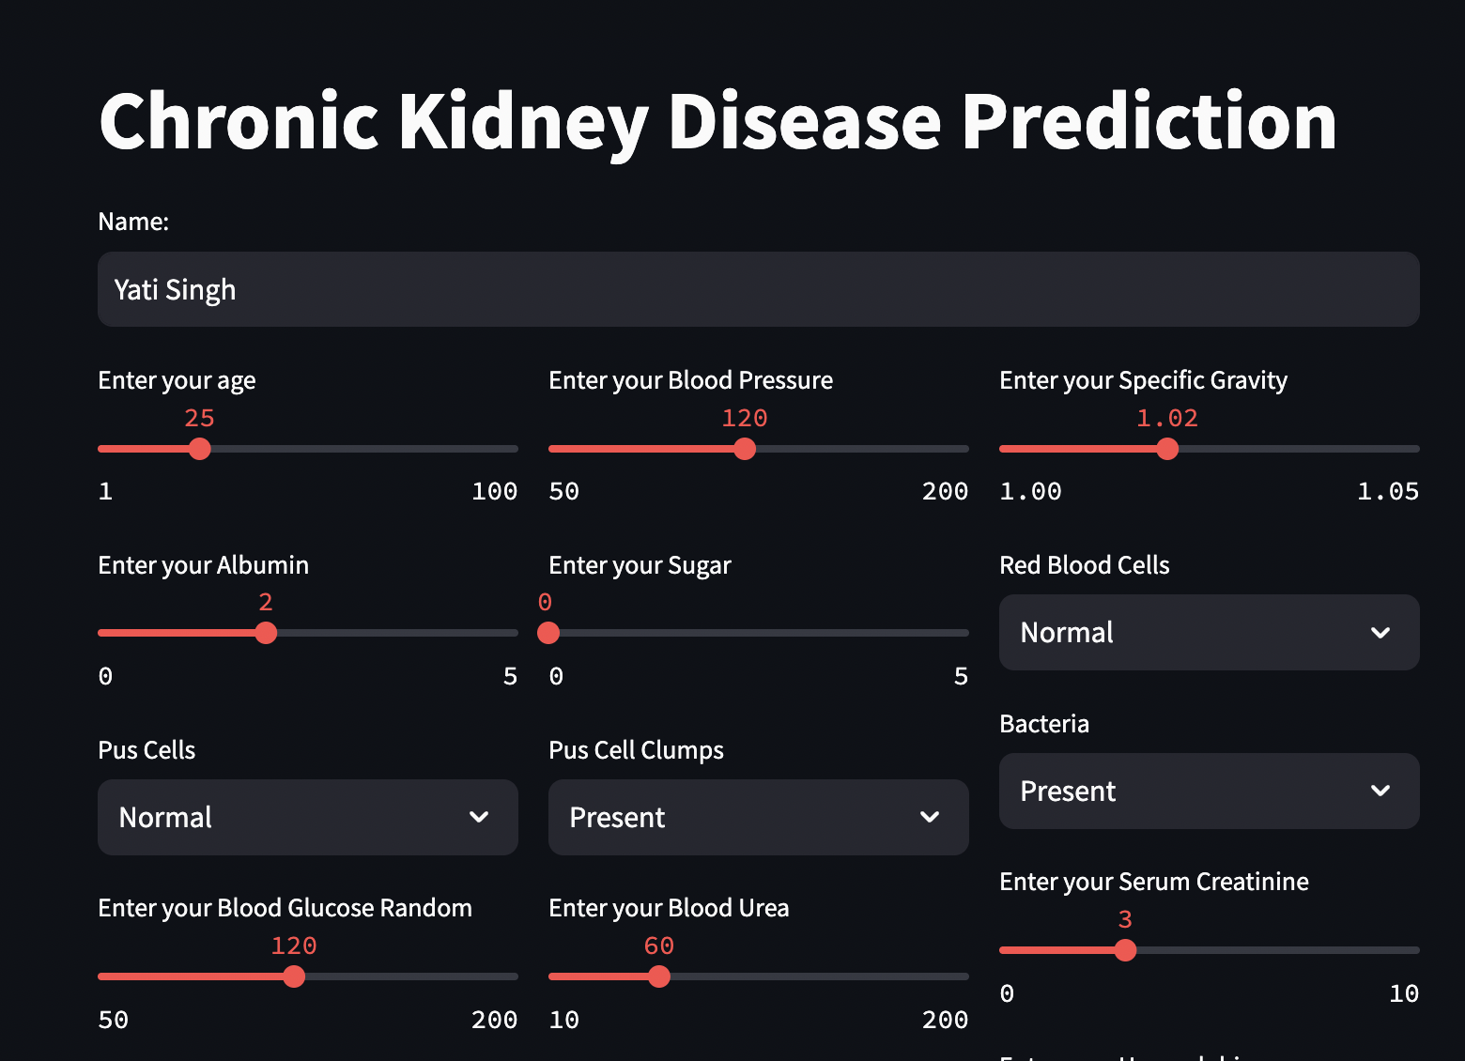
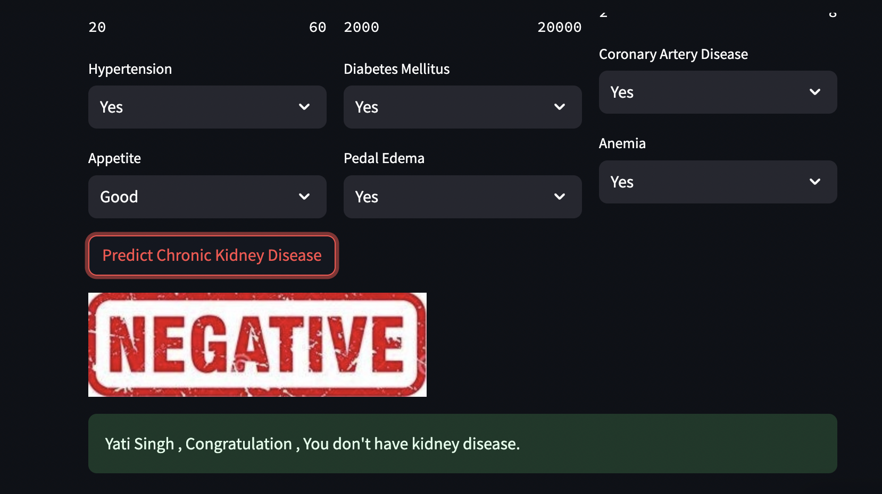
Fig(d)

